Supplementary Material
Primary cilia regulate the mechanical adaptation of the tendon and enthesis via hedgehog signaling
Enhao Zhang¹, Alina Feng¹, Linda Liang¹, Angel Moonilall¹, Fei Fang^{1, 2 *}
¹Department of Orthopedics, Icahn School of Medicine at Mount Sinai, 10029, New York, NY, USA
²Institute for Regenerative Medicine, Icahn School of Medicine at Mount Sinai, 10029, New York, NY, USA
*Correspondence: fei.fang@mssm.edu (Fei Fang)

ORCID:
Enhao Zhang: 0009-0001-0837-7684
Fei Fang: 0000-0002-6706-6886

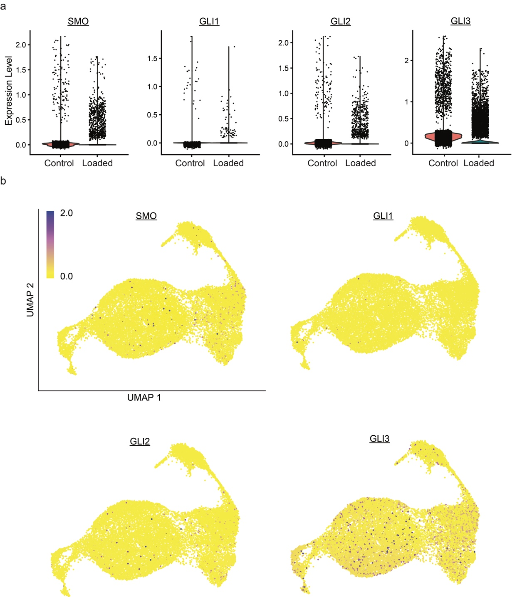
Supplementary Fig. 1. Expression of Hh-related genes (i.e., SMO, GLI1, GLI2, GLI3) in human control and loaded samples shown by (a) violin plots and (b) feature plots.

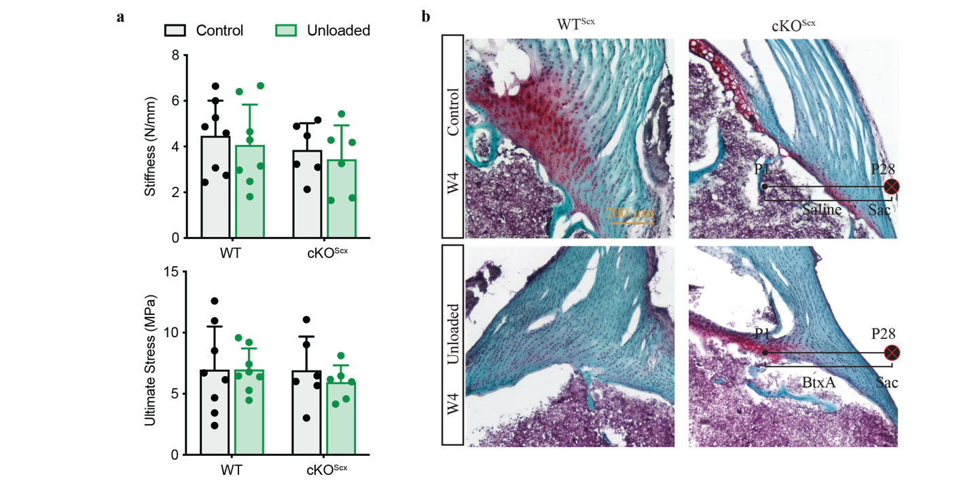
Supplementary Fig. 2 Cilia deficiency blocks loading-induced tissue remodeling. a Tendon enthesis stiffness and stress from WTScx (Ift88fl/fl) and cKOScx (ScxCre;Ift88fl/fl) mice measured by mechanical testing. b Safranin O staining of the tendon enthesis showing decreased fibrocartilage region (red) of WTScx mice after unloading, compared to control, but cKOScx mice showing negligible structure difference of the tendon enthesis after unloading (scale bar = 200 μm). Unloading was achieved by local injection of 0.2 U BTxA into the shoulder from birth to 4 weeks of age, whereas control mice received an equal volume of saline over the same period. n = 6-8 mice/group in (a) and (b). Data are shown as mean ± SD. Two-way ANOVA analysis with multiple comparisons using the Sidak multiple comparisons test was performed.

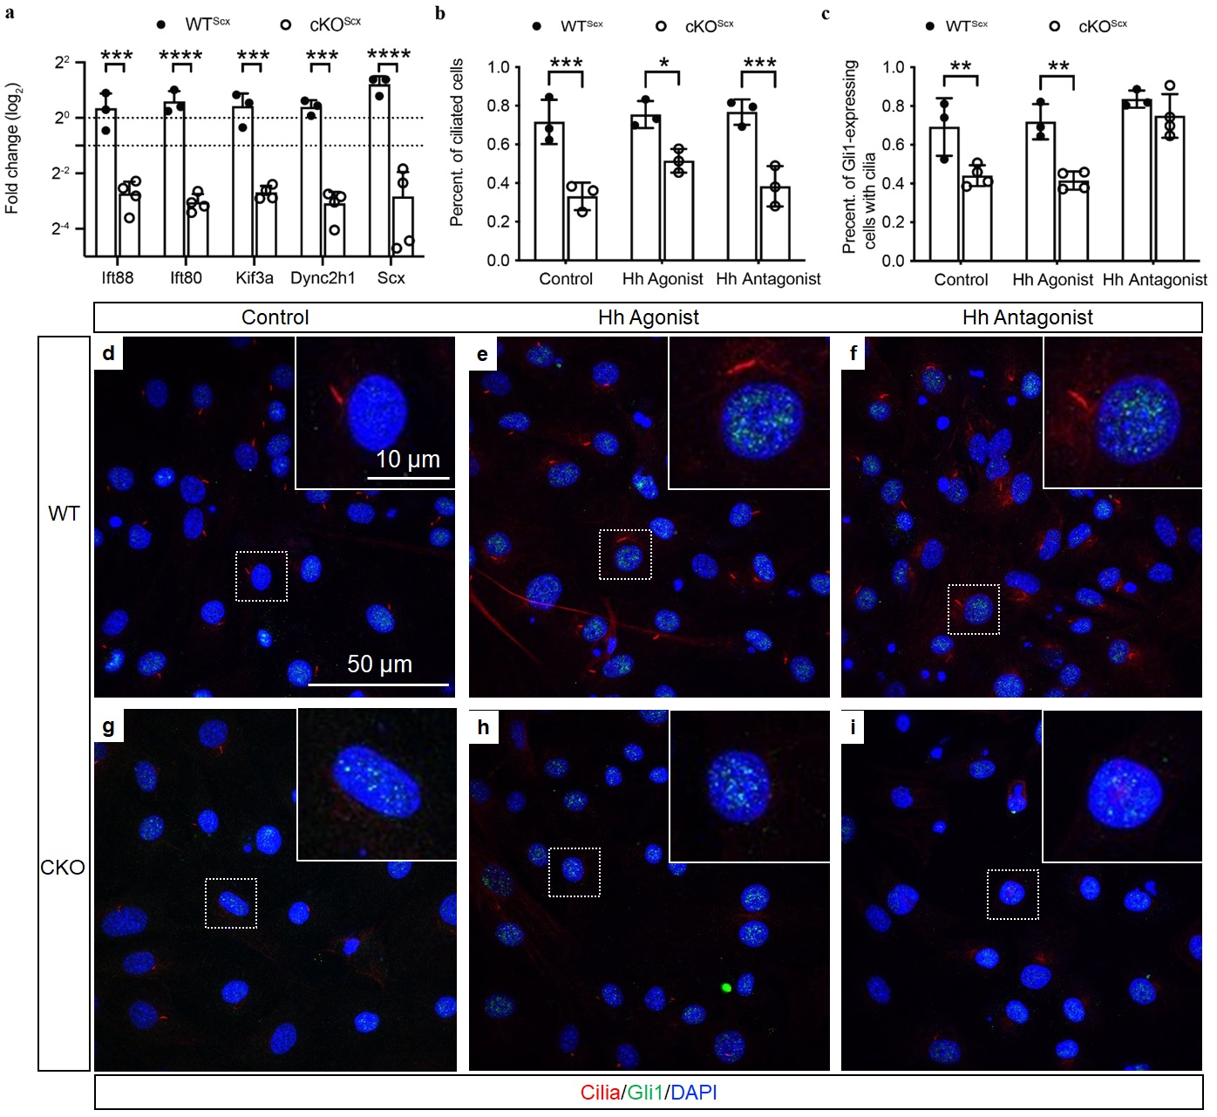
Supplementary Fig.3 Ciliation is independent of Hh signaling in tail tendon cells in vitro. (a) Tail tendon cells from cKO^{Scx} (ScxCre;Ift88^{fl/fl}) mouse models have significantly decreased cilia-related (i.e., Ift88, Ift80, Kif3a, Dync2h1) and tenogenic (i.e., Scx) genes, compared to WT^{Scx} (Ift88^{fl/fl}) mice, demonstrating knockout efficiency in cilia. (b-c) Immunostaining analysis of tail tendon cells treated with Hh agnonist Hh-Ag1.5 and Hh antagonist cyclopamine shows that both the percentages (percent.) of ciliated cells (normalized by the total cell number) and GLI1-expressing cells with cilia (normalized by the cell number of GLI1-expressing cells) decrease in cKO^{Scx} cells, but ciliation is muted from Hh activation or inactivation. (d–i) Representative immunofluorescence images of WT^{Scx} and cKO^{Scx} tendon cells under control conditions or following treatment with Hh agonist or antagonist. Cells were stained for acetylated tubulin (cilia, red), GLI1 (green), and DAPI (nuclei, blue). Scale bar, 50 μm. n = 3-4 mice/group. Data are shown as mean ± SD. Unpaired Two-sided Student’s t test for data analysis is performed in (a), and two-way ANOVA analysis with multiple comparisons using Sidak multiple comparisons test is conducted in (b) and (c). *, p < 0.05; **, p < 0.01; ***, p < 0.001.

